SOP of PecStar Client Workstation Installation
Please follow this guide to begin to PecStar Client Installation.
- Insert the PecStar Installation DVD to the DVD drive. If it does not open automatically, use Windows Explorer to navigate to folder and double-click setup.exe.
- Select a Setup Language and click Next.
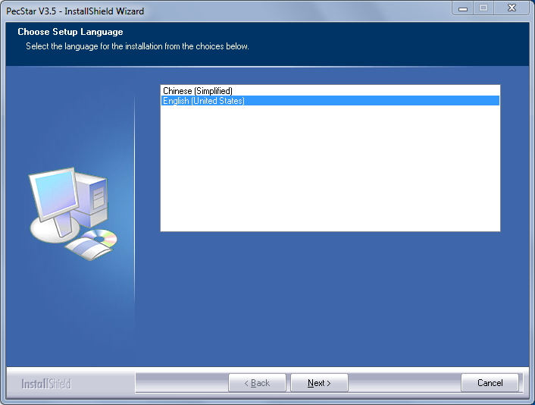
- Click Next.
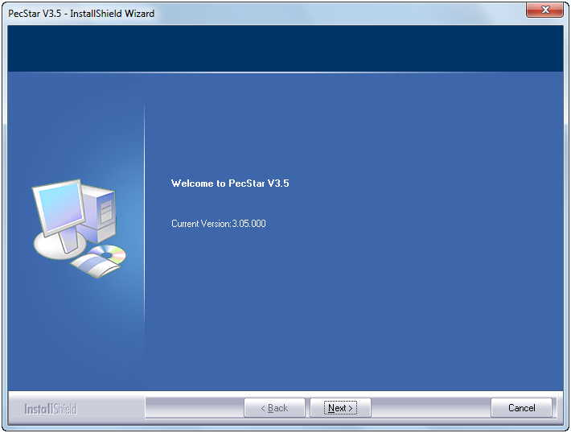
- Select the authorization mode and click Next.
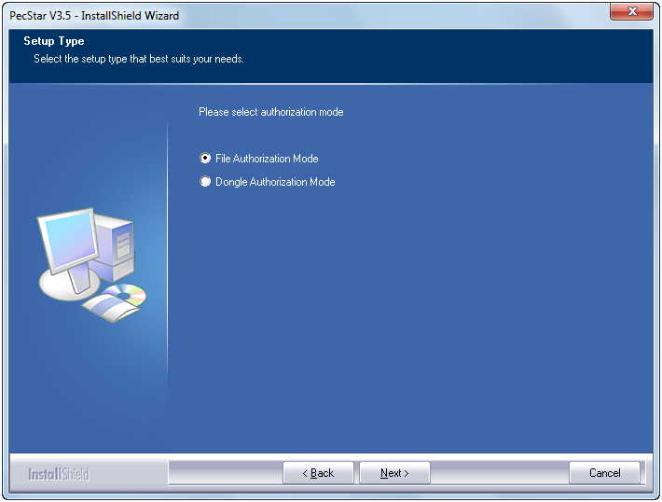
- For File Authorization Mode, PecStar will offer you the Computer Characteristic Information as followed. Send this to CET Electric Technology to get the corresponded authorization file (swlic.dat).
Click Next and it will bring you the checking running environment window.
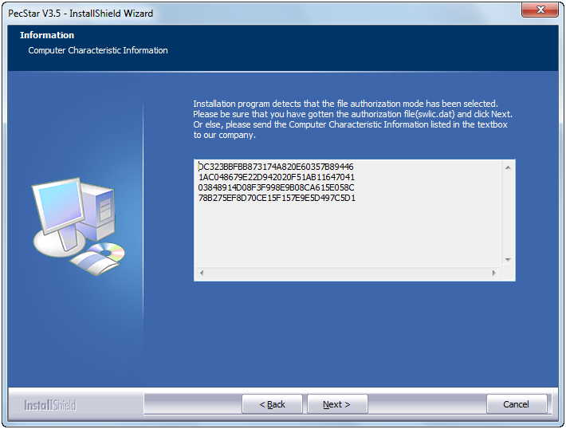
- For Dongle Authorization Mode, PecStar will install the Dongle driver. Select the Setup Language and click Next.

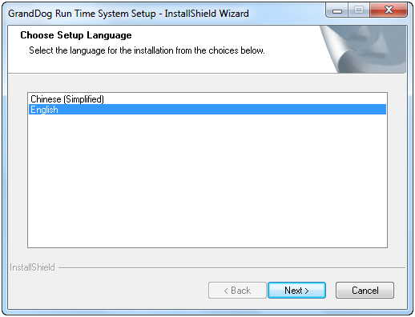
Wait until the installation finished, click Finish and it will bring you the checking running environment window.
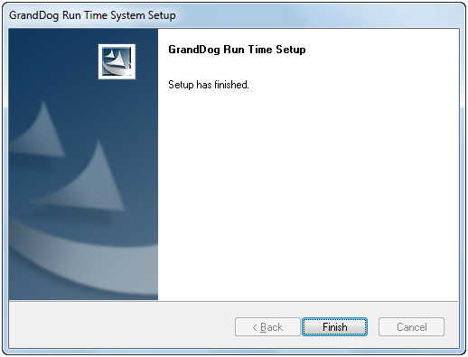
- The Installation program will check the following environments.
Windows Installer 4.5
.Net Framework 4.0
Visual C++ 2010 Running Time Library
Flash Player 10
And it will automatically install the missing ones.
Then click Next to the next step.
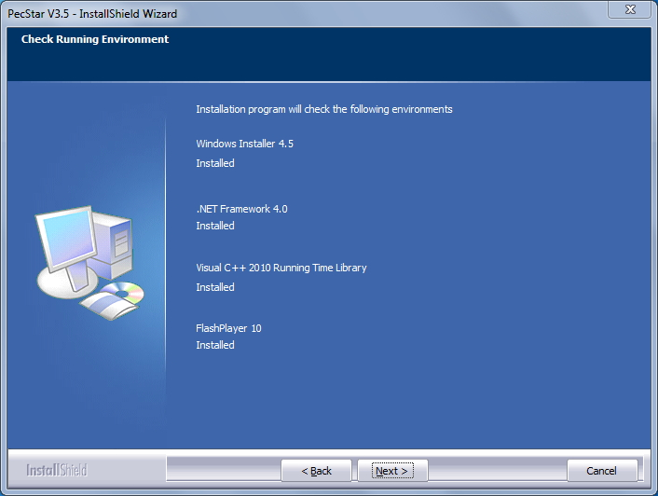
- Read the License Agreement. If you agree, select I accept the terms of the license agreement, and click Next.
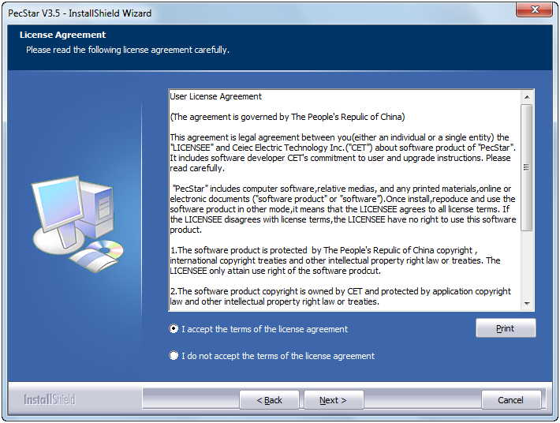
Note: Due to business development, since April 10th, 2017, Ceiec Electric Technology Inc. has been renamed to CET Electric Technology Inc., however, the products (including hardware and software) that were developed or manufactured before this date may still involve old name or logo.
- Select a Setup Type, for Client Installation, Please select Custom.
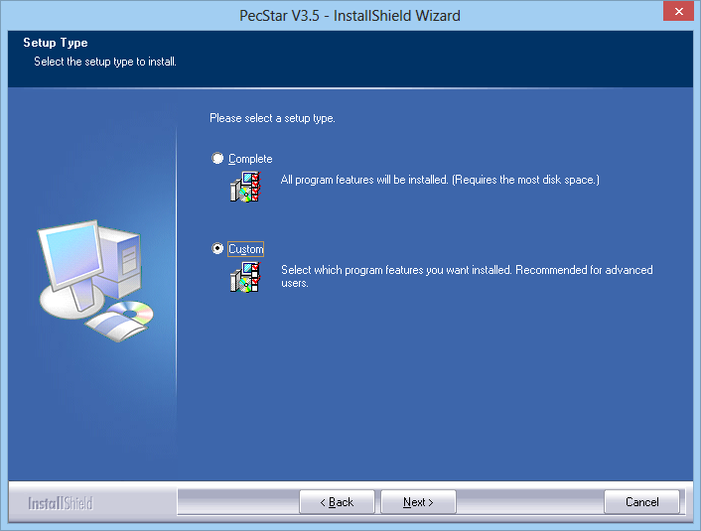
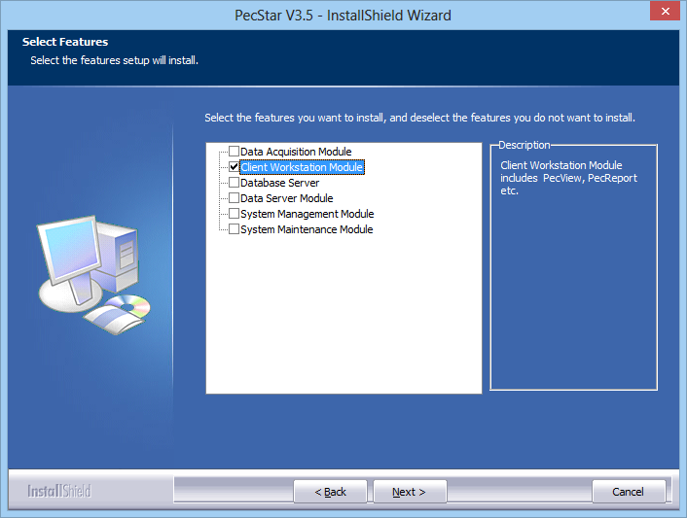
- Choose the installation path of PecStar, or keep the default location (D:\CET). Click Next.
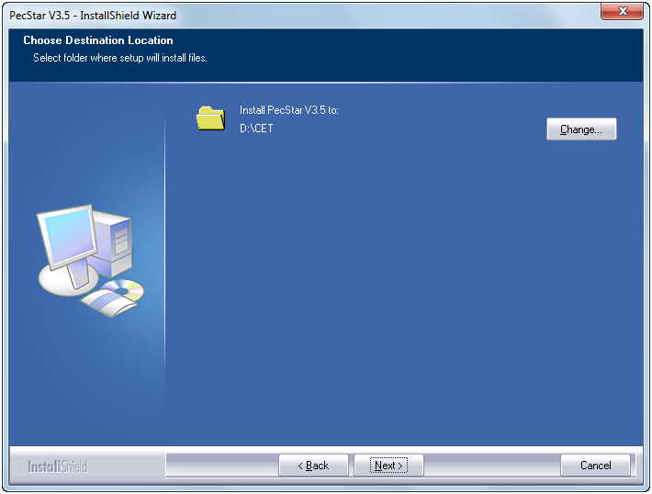
- You can enter the user name and the company name.
For File Authorization Mode, input the Serial Number and choose the location of the Authorization File. (swlic.dat).
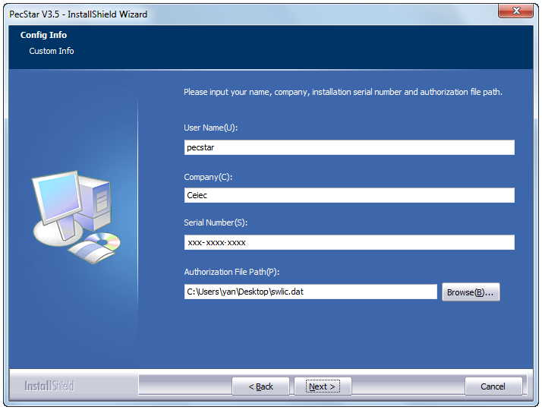
For Dongle Authorization, input the Serial Number and Password of the dongle.
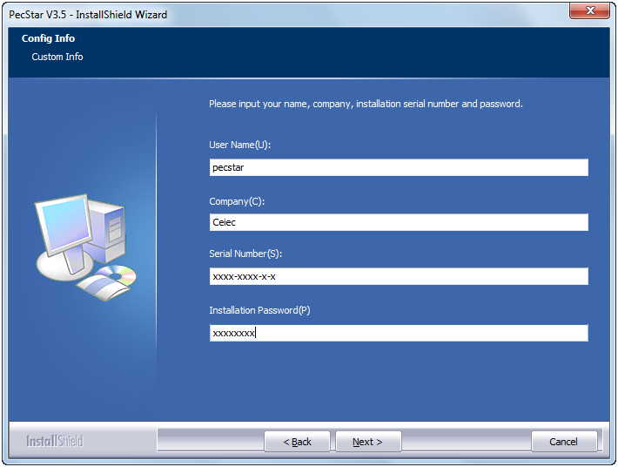
Verify the information and click Next.
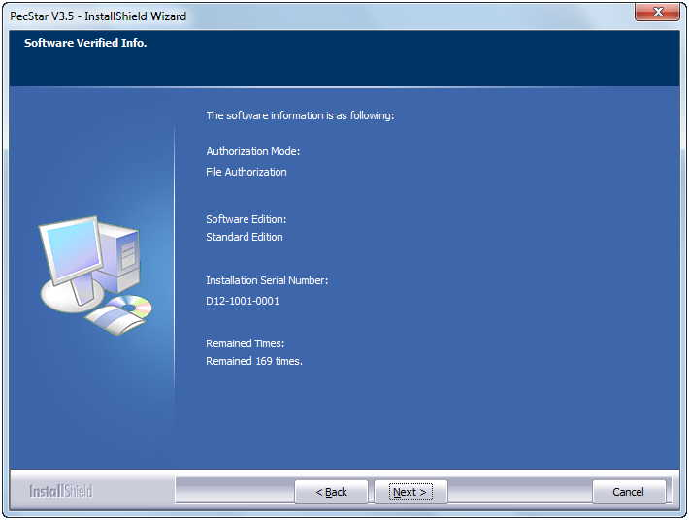
- Input the Main and Standby Data Server’s Computer Name. It can be local or remote.
If you don’t have a Standby Data Server, keep it blank.
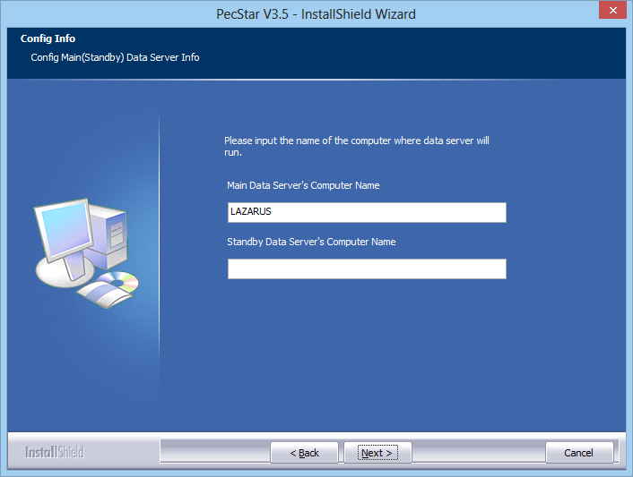
- Input the Database Server address. The Database Server can be local or remote.
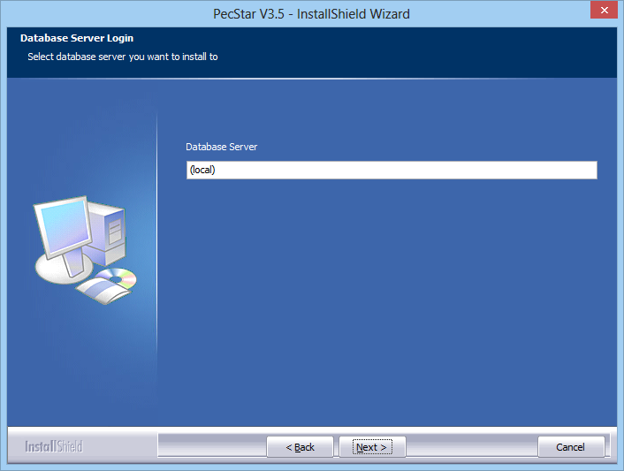
If you are not sure, you can open SQL Management Studio and copy the Server Name.
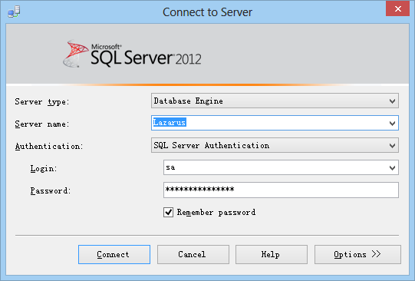
Then click Next.
- Input the correct Login ID (sa) and password. Click Next.
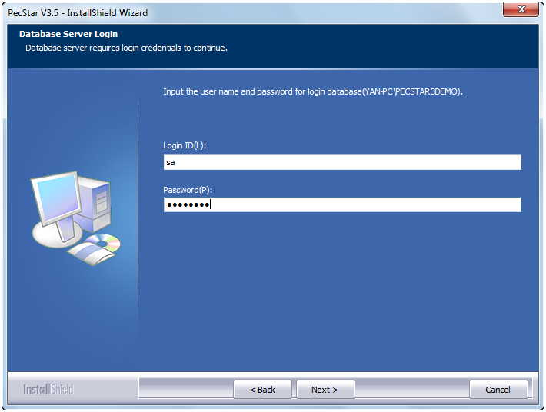
- Select whether to configure standby database.
It is not required to configure standby database unless you need another Database Server for backing up your main database.
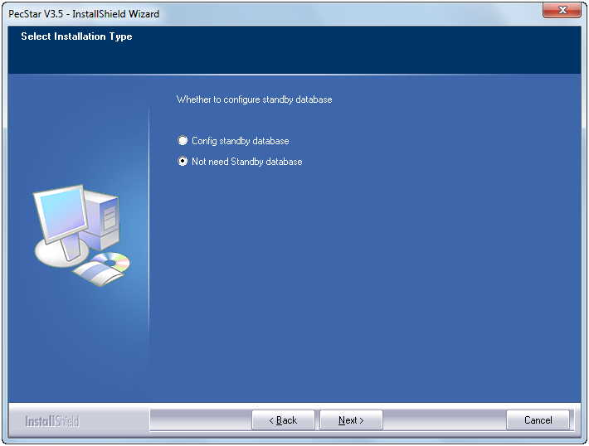
- Input the Project Name of PecStar
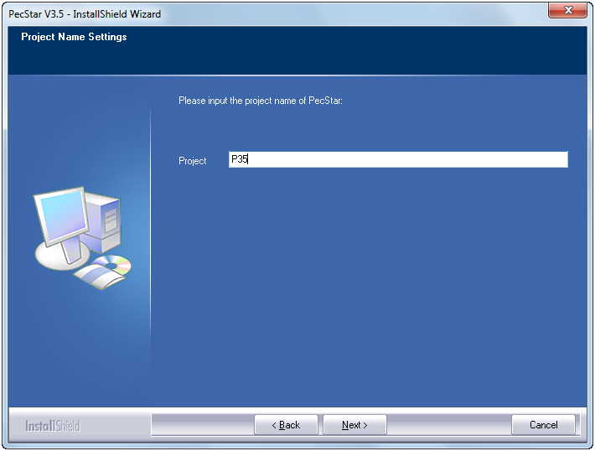
- The Installation Shield Wizard will check if the project exists.
If the project exists, it will go to the next step. Otherwise it will show you the below message.

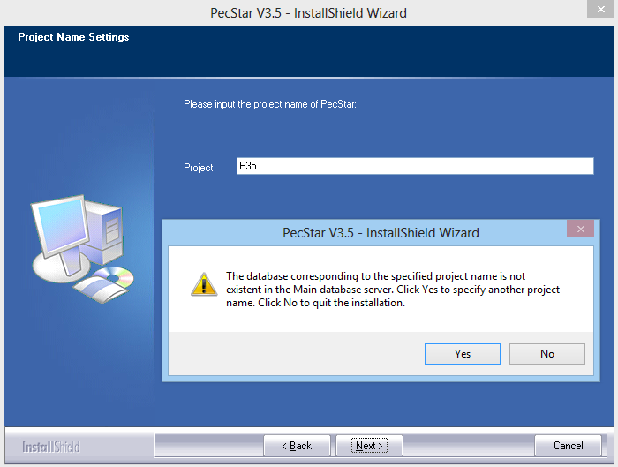
- Then you can choose to use the existent database or input another project name.
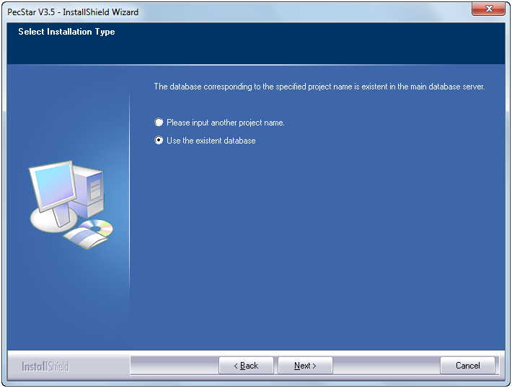
- If you choose use the existent database, the program will check the database version.
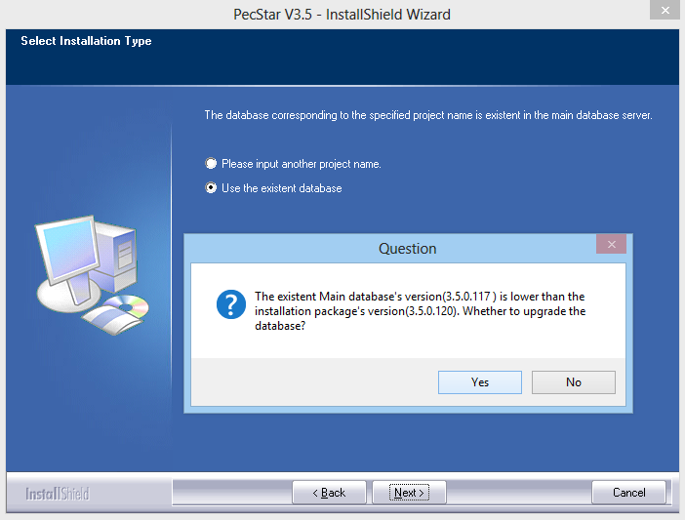
Click Yes.
- Click Install to begin the PecStar installation.
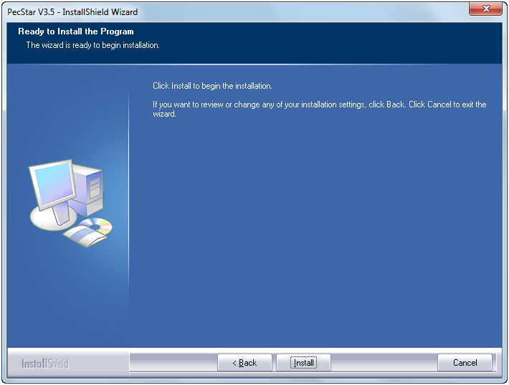
PecStar will show you its features during installation.
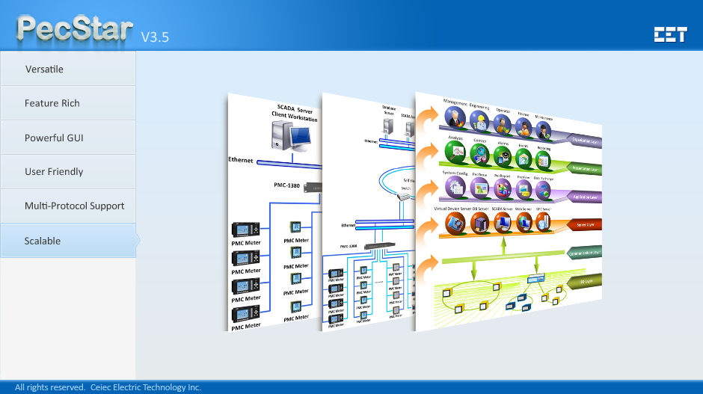
- Wait a moment until the installation finishes. Then you can choose to Run the user wizard immediately or after a moment, then click Finish.
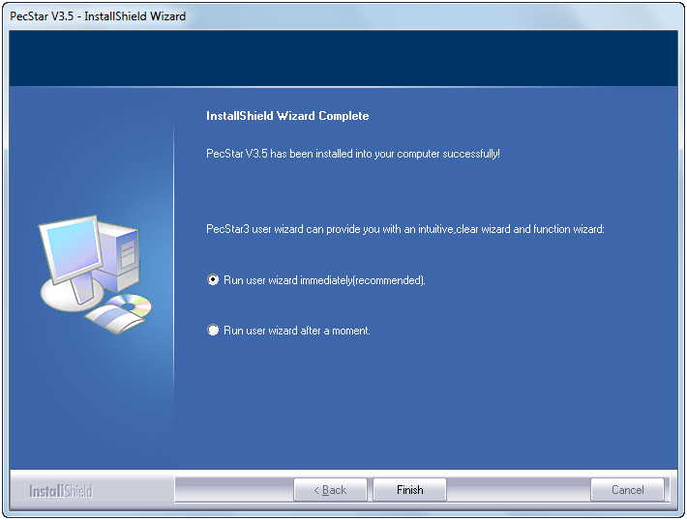
- The program will create a PecStar Assistant shortcut on the desktop which will help you quickly open the most common used programs.
